Revised Adult Education Block Grant
Annual Plan Template for 2015-16
Updated 10-7-2015

Section 1: Consortium Information

1.1 Consortium Grant Number:
13-328-26
1.2 Consortium Name:
Long Beach Adult Education

1.3 Primary Contact Name:
Michael J. Bastine

1.4 Primary Contact Email:
mbastine@lbcc.edu

If applicable:

1.5 Fiscal Agent Name:
1.6 Fiscal Agent Email:
cortega@lbschools.net
Carol Ortega

1.7 Identify each member organization currently within your Consortium, and your Consortium representative.
Table 1.7 – Consortium Membership (add rows as needed)
1.7a. Organization | 1.7b. Representative Name | 1.7c. Representative Phone | 1.7d. Representative Email | 1.7e. Date Officially Approved
LBCCD | Dr. Terri Long | 562.938.4209 | tlong@lbcc.edu | 9/8/2015
LBUSD | Carol Ortega | 562.997.8122 | cortega@lbschools.net | 10/5/2015
LBUSD | Dr. Felicia Anderson | 562.595.8893x289 | fanderson@lbschools.net | 10/5/2015

1.8 Use the Governance Template to describe how your Consortium operates programmatically and fiscally.
See separate LBAEC Governance Templet File

1.9 Attach an organizational chart to this plan submission. Show member relationships (including reporting) and interface with key partners, and identifying the fiscal agent (if applicable) and primary contact. See Guidance for sample and definitions.

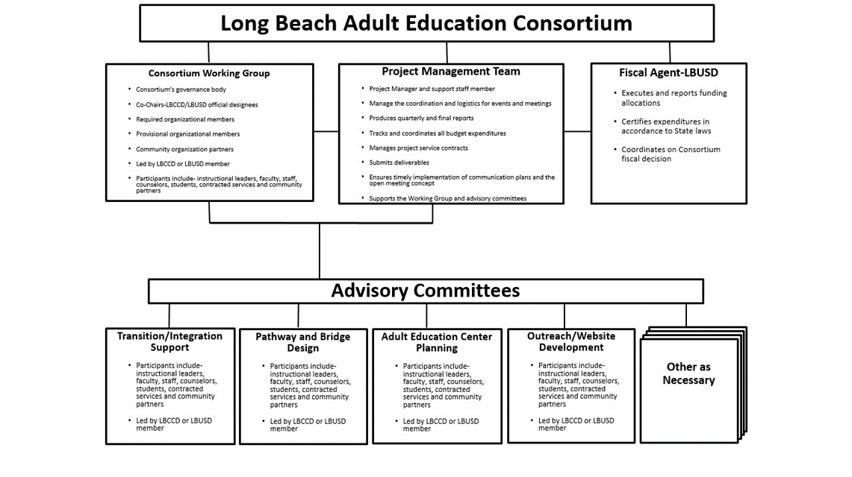

1.10 Whether using a single fiscal agent or not, describe how you are fiscally managing your block grant. How are you rolling up grant expenditures to certify and report to the State? Who will be your Certifying Officer?

Our fiscal agent LBUSD, has had a close relationship with LBCCD on various regional projects. LBUSD faculty and staff will be directly involved with the working group and the specific advisory committees supporting the consortium. As a voting member of the working group, our fiscal agent will stay abreast of the various action plan initiatives and will understand the expenses that will occur in accomplishing our annual plan. Bi-annual budget and performance reports will be coordinated between the Project Management Team and the fiscal agent. All Consortium’s reports to the State will be signed off by the official consortium representatives before being submitted.

Section 2: Plan Summary for Program Year 2015-16

The AEBG effort focuses on the this purpose described in AB86: “… to rethink and redesign an educational system that creates seamless transitions for students across adult schools and community colleges to accelerate academic and career success in order to earn a living wage.” Your AB104 Adult Education Block Grant Three-Year Plan Update summarizes what your Consortium’s vision and goals are for your regional Adult Education system by the end of the three-year implementation period (by the end of program year 2017-18). The annual plans will focus on what will be done to make progress towards that vision.

2.1 Provide an Executive Summary regarding how your Consortium proposes to make progress in program year 2015-16 towards the realization the vision and goals of your Consortium’s AB104 AEBG Three-year Plan referred to above. What will your system look like by the end of 2015-16? See Guidance document for more information about this narrative.

EXECUTIVE SUMMARY

The Long Beach Adult Education Consortium (LBAEC) is comprised of two member institutions, Long Beach Unified School District (LBUSD) and Long Beach Community College District (LBCCD).

The Long Beach Consortium embraces the concepts of transparency and inclusiveness within its structure and governance. Student focused with faculty, community leaders, and the public-at-large participation, the LBAEC will effectively meet the needs our adult learners in a timely manner. The Long Beach Consortium plans to achieve within the first year: the creation of the Long Beach Adult Education Center, to provide transition support for adult learners through the Adult Education Center and its working group; maintain, enhance, and evolve the LBAEC website; expand consortium outreach, rapport building, and communication; evaluate the Adult Education Center’s overall effectiveness towards Adult Education for the consortium region; and to perform consortium-wide participation in conferences, meetings, professional development, and other collaborative initiatives. Members and partners of the Consortium will collaborate together to achieve these milestones. Student enrollment, participation with program initiatives, and student intake data will be used to measure the progress in closing the adult education gaps. Additional data to measure program effectiveness will include - existing rubric metrics, certificate completion, high school equivalency tests, attendance rates, and student satisfaction surveys. Continuous improvement and assessment of program effectiveness toward adult learners will be the consortium’s constant focus.

Section 3: Consortium Services and Funding Allocations
3.1 Consortium Services by Program area, Member and Funding Source (Estimated). Please identify the types of services your Consortium will provide, and the funding that will go to support these efforts. Information about Levels of Service will be gathered in Section 6. Using the Member Allocations Workbook for Table 3.1, Consortium Members will fill out their own spreadsheets. The spreadsheets completed by individual Members will automatically be totaled together to provide the Consortium level figures on the Summary Sheet of the Workbook. Below is an overview of the information required.
Administration and MOE Indirect amounts are captured in Table 3.2b. The amounts entered in Table 3.1 should not include those expenses.
Table 3.1 Consortium Services by Program area, Member and Funding Source (Estimated)

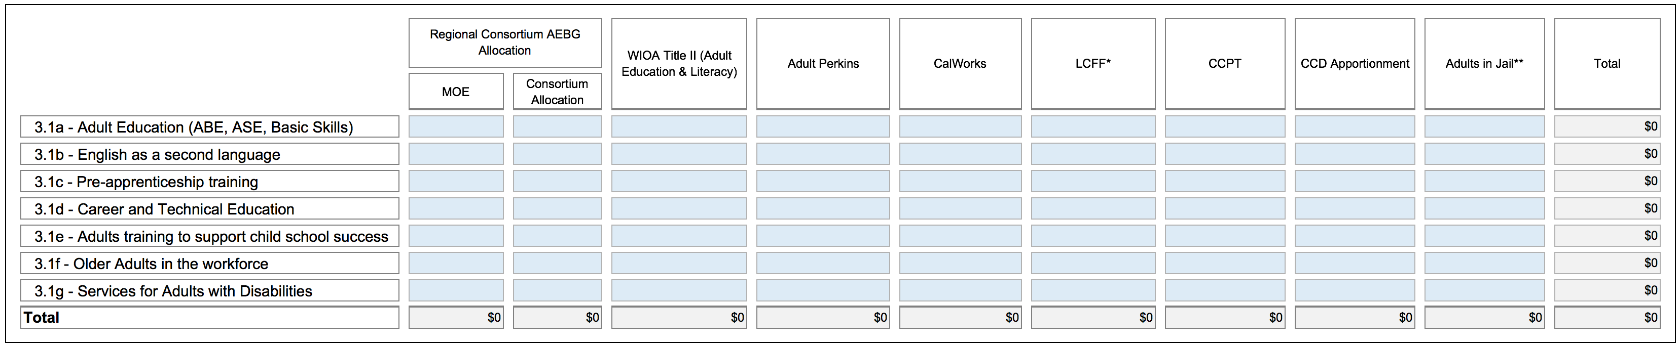
EXAMPLE

REVISED 3.2 Consortium AEBG Allocations by Member (Estimated).
NEW INSTRUCTION: Table 3.2 will capture total AEBG MOE and Consortium Allocations, and the amounts of those figures that will go Administration (5% cap) and the MOE Indirect amount that will be charged to the AEBG. Using the Member Allocations Workbook for Table 3.2, Consortium Members will fill out their own spreadsheets. The spreadsheets completed by individual Members will automatically be totaled together to provide the Consortium level figures on the Summary Sheet of the Workbook. Below is an overview of the information required.
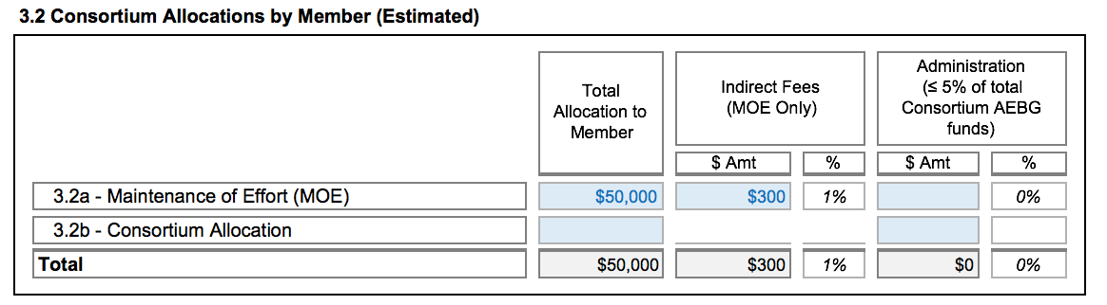
EXAMPLE
Section 4: Overview of 2015-16 Action Plans
Building off of your AB86 Final Plan, your AB104 Three-Year Consortia Plan Update and expected accomplishments for the 2015-16 program year, briefly outline your Consortium’s top 3-5 key activities for each of the Plan Objectives listed below for 2015-16. The original AB86 Objectives language has been adapted to the AB104 AEBG context.
4.1 Objective 3: Integrate existing programs and create seamless transitions into postsecondary education or the workforce. How will the Consortium align and connect existing and future adult education programs to postsecondary academic pathways and/or career pathways leading to employment? Activities should address how the Consortium will align placement tools, curriculum, assessment tools and rubrics, and student performance outcomes across delivery systems to ensure that student transition paths, both between providers and into postsecondary credit programs, are understood and supported across all systems.

Plans to facilitate transitions from adult education to college or career should include activities to support program alignment and pathways. Plans should also address support services needed to ensure that students have access to educational advising and that they develop educational plans to help them move toward their academic and career goals. Describe the specific activities the Consortium will employ to create the following:
● Educational pathways
● Alignment of:
○ Placement
○ Curriculum
○ Assessments
○ Progress indicators
○ Major outcomes - i.e., awards of high school diplomas, CTE certificates, etc.
● Transition strategies among the Consortium participants’ systems including:
○ Communication paths among Consortium participants and higher education institutions
○ Defined and articulated pathways to postsecondary education or the workforce
○ Embedded access to student services including counseling, guidance, and follow-up

4.1a Provide a description of your AEBG Regional Assessment Plan, i.e. how students will be appraised, placed, assessed, etc. into the regional adult system, as they progress, and as they move among the various schools. What tools and vendors will you be using for these activities?
LBUSD
The Long Beach School for Adults (LBSA) has developed and implemented the following local procedures for assessment and data collection consistent with the California Department of Education’s (CDE) Workforce Investment Act Title II: Adult Education and Family Literacy Act, Assessment Policy Guidelines for 2015-16.
The LBSA Regional Assessment Plan includes a multi-tiered response to the in-take processes and matriculation through the HiSET and ESL Programs. Within each program are assessment and instructional monitoring protocols that ensure student support.
The HiSET Program begins with the in-take assessment. 1. TABE (Test of Adult Basic Education): Students take a multiple choice reading comprehension assessment and receive a grade level score. 2. TABE score determines English Language Arts level of instruction in the HiSET program. Level One indicates reading below 10.0 grade level and Level Two indicates reading at grade 10.0 or above. 3. Students take a CASAS assessment at Orientation. Some students earn a promotion from Level One to Level Two if the CASAS score is 10.0 or higher.

LBCCD
LBCCD uses Accuplacer tests for placement in English, Reading and Math. The Accuplacer Sentence Skills test has multiple choice questions and is untimed. The test questions are presented in a computer adaptive mode. Possible placements range from ESL class placement to English 1. If learners self-identify as non-native speakers of English, they take a written placement test in the ESL office, and not the Accuplacer test. Additionally, the ESL department provides a more specific placement through an evaluation of students’ placement test essays. The Department has one ESL Services Specialist who supervises the placement process and a Department Head who assists students with placements and placement appeals through counseling and multiple measures. Furthermore, there is on- going assessment of students’ competence and performance by ESL instructors to make certain that students are placed in the appropriate ESL classes by the two assessment processes.

The following are several potential vendors and tools that could be investigated and selected to appraise, place and assess students in the regional adult system. 1. Administrative Software Applications, Inc. ASA developed a proprietary student information system, called ASAP which includes classroom management software as well as student tracking that allows for extraction of data reports on student performance. 2. McGraw-Hill Workforce Connects is an online system that offers a variety of assessments that measure skills in the areas of Applied Mathematics, Locating Information, and Reading for Information. 3. Learning Resources Inc. (LRI) provides tools that enable employers and workforce professionals to measure, develop and document the soft skills required for work readiness and workplace effectiveness. LRI enables organizations to align the skill demands of employers with the competencies of future workers, and measure and develop adults' and youth's interpersonal (soft) skills, and assess applicants and future workers for jobs that range from entry-level to high-performance to supervisory positions, and address soft skill deficits. 4. National External Diploma Program (NEDP) is an applied performance assessment system that assesses the high school level skills of adults and out-of-school youth. The NEDP evaluates the reading, writing, math and workforce readiness skills of participants in life and work contexts. Assesses high school level skills awarding a traditional diploma so graduates can meet their academic and career goals. Designed for self-directed youth and adults with life and work experiences and a general familiarity with the computer. Evaluates competencies in ten content areas including Financial Literacy, Health Literacy, Civic Literacy, Geography, History, Science, and Twenty-First Century Workplace. Evaluates competencies that are based on skills outlined in the Common Core College and Career Readiness standards.

4.1b Describe how you will track student enrollment, demographics, and performance. What system(s) will you be using? How will you collect the data from the student/classroom level? How will this system enable you to meet the targeted program outcomes?

LBUSD

HiSET and ESL Program Tracking

Data collection for Comprehensive Adult Student Assessment Systems (CASAS) interfaces with the two primary software programs called TOPSpro Enterprise and ASAP. The two systems track program enrollment, attendance, and testing.

Student information is entered into the ASAP system by adult school office staff from the registration form which students fill out upon enrollment. Student employment status, education, and income level are part of the information collected from students at registration.

Long Beach School for Adults (LBSA) employs a School Data Technician to coordinate TOPSpro Enterprise, enrollment, and attendance. The Data Technician facilitates the reporting of outcomes and the monitoring of the program’s performance against the state’s performance measures. It is the responsibility of the Data Technician to certify that the data collection is correct. Procedures for correcting errors and resolving issues are directed to the Data Technician, who corrects or resolves any issues within the software programs.

Teachers are responsible for tracking attendance of students using the Web Teacher Attendance system in ASAP. Teachers complete the Student Update record at the end of each term, whereas the Data Technician enters the Updates. Teachers and office staff administer the CASAS test assessments to students, and the Data Technician scans and downloads the answer sheets into the TOPSpro Enterprise System.

Data from TOPSpro Enterprise and ASAP is used to monitor and improve all programs. The attendance reports, the Next Assigned Test, the Learning Gains, and Benchmarks help to determine the teacher’s effectiveness and accountability. Generated reports assist teachers to identify strengths and areas needed for further instruction. Students become invested in their learning because they track and monitor their own progress and achievement on CASAS tests. The data is used by staff for learning outcomes, for program scheduling, and for transitioning students into the next level or program.

Teachers meet individually with students to review test scores, attendance patterns, and class participation levels and how the three are interrelated. Students are encouraged to set goals to increase their attendance, participation, and to focus on areas of weakness as indicated by test scores.
LBCCD
Administrative Software Applications, Inc. ASA developed a proprietary student information system, called ASAP which includes classroom management software as well as student tracking that allows for extraction of data reports on student performance.
TOPSpro is a computerized database system designed for students, teachers, and program administrators in adult education. TOPSpro automates CASAS scoring, collects student demographic data, tracks student progress, generates reports and profiles, and manages data for state and federal accountability.
The Long Beach City College Data Warehouse is a resource that facilitates reporting and analysis. It is based on the IBM Cognos 8 Business Intelligence suite of applications.
Certificates of graduation numbers; Number of students who enroll in college; Number of students who transfer to college; Track post-graduate employment; Number of students who pass the HSE; Data and surveys; Number of students who enroll; Track post-graduate employment

4.1c – Objective 3 continued: List other activities to integrate existing programs and create seamless transitions into postsecondary education and/or the workforce.

Table 4.1c – Objective 3: Other Key Integration and Seamless Transition Activities (add rows as needed)
4.1c(1). Activity | 4.1c(2). Timeline | 4.1c(3). Consortium Members Involved | 4.1c(4). Outcomes  Expected | 4.1c(5).Method of Assessing Impact
Campus Tours | Fall 2015/Spring 2016 | LBCCD/LBUSD | Student awareness Begin registration process | Survey
Common Adult Ed. Counselors | Spring 2016 | LBCCD/LBUSD | Students participating at both locations | Sign-in registration
Long Beach School for Adults (LBSA) Students Creating LBCCD Student Education Plans (SEP) | Spring 2016 | LBCCD/LBUSD | Student SEPs accomplished | Number of new SEP by LBSA students
Lunch and Learn with Potential Community Partners | Spring 2016 | LBCCD/LBUSD | Recruitment participation from community partners | Consortium’s participation
IBEST Practices | Spring 2016 | LBCCD/LBUSD | Program awareness and understanding | Consortium’s participation

4.2 - Objective 4: Activities to address the gaps identified in Objective 1 (evaluation of current levels and types of adult education programs within its region, and Objective 2 (evaluation of current needs for adult education programs within the Consortium’s region), updated in your Updated AB104 3-year Plan. Describe how the Consortium will respond to the gaps identified in the region. These might include, but are not limited to, working with other partners in the service area, developing or expanding programs and plans to assess the effectiveness of these expanded efforts.

Plans will have identified programming and service gaps including lack of providers, services, access, attainment, and/or performance. Activities to address these should include strategies to incrementally increase capacity in identified gap areas (e.g., using distance learning to reach adult populations in a Consortium’s region who are currently underserved).

Table 4.2 - Objective 4: Key Activities for Addressing Gaps (add rows as needed)

4.2a. Activity | 4.2b. Timeline | 4.2c. Consortium Members Involved | 4.2d. Outcomes  Expected | 4.2e. Method of  Assessing Impact
Build Adult Education Center and Increase Resource Capacity to include Personnel, hardware, and software | Spring 2016 | LBCCD/LBUSD | Development of Staff positions and facilities to begin operations.  Hire additional faculty and staff.  Acquire HW/SW. | SEPs, Center Sign-ins, and Surveys
Transition Pathways | Spring 2016 | LBCCD/LBUSD | CTE alignments developed and Bridge programs defined | 2 CTE Specific Pathways identified and developed
Website Development | Spring 2016 | LBCCD/LBUSD | Internal and External Internet Resource | Usage counter, meeting postings, and general information for students and staff
Outreach | Spring 2016 | LBCCD/LBUSD | Campus tours/ orientations, advertisements, and greater community participation | Student participation, SEPs, meeting participation levels and website/AE center contacts
Professional Development | Spring 2016 | LBCCD/LBUSD | Collaboration participation | Number of attendees participating and best practices adopted
Student Enrollment Funding | Spring 2016 | LBCCD/LBUSD | Increase LBSA student enrollment and retention | Student enrollment numbers

4.3 - Objective 5: Employ approaches proven to accelerate a student’s progress toward his or her academic or career goals, such as contextualized basic skills and career technical education, and other joint programming strategies between adult education and career technical education. Research has emerged in recent years identifying practices that reduce the time it takes for adult learners to progress through basic skills and career education pathways. Common strategies include compressing courses into shorter, more intensive terms (accelerated), individualized instruction based on a student’s competencies (competency-based), and putting basic skills content into the context of a student’s goals and career path (contextualized).
Many examples of these “best practices” are already in place within and among California adult education and community college programs. These “best practices” are not new to faculty; in fact, they have been developed by faculty. AB104 expects that the work done by regional consortia will include plans to make use of these strategies within their basic skills and career programs and in joint programming strategies.
In many places in the country, Integrated Basic Skills Training (IBEST) models, which contextualize the development of basic skills with the acquisition of workforce competency, have produced impressive data showing how learning can be accelerated while joining skills development with career readiness certifications. The AB104 website will continue to build links and resources tied to best practices and research done through adult education and community colleges.
Identify activities that you will implement and/or improve through using specific evidence-based strategies across the region, within and between systems where they currently don’t exist, to accelerate student’s progress.
Table 4.3 - Objective 5: Key Activities for Accelerating Student Progress (add rows as needed)
4.3a. Activity | 4.3b. Timeline | 4.3c. Consortium Members Involved | 4.3d. Outcomes  Expected | 4.3e. Method of  Assessing Impact
Build Adult Education Center and Increase Resource Capacity to include Personnel, hardware, and software | Spring 2016 | LBCCD/LBUSD | Development of Staff positions and facilities to begin operations.  Hire additional faculty and staff.  Acquire HW/SW | SEPs, Center Sign-ins, and Surveys
Transition pathway development | Spring 2016 | LBCCD/LBUSD | CTE alignments developed and Bridge programs defined | 2 CTE Specific Pathways identified and developed
Website Development | Spring 2016 | LBCCD/LBUSD | Internal and External Internet Resource | Internet Usage counter, meeting postings, and general information for students and staff
Outreach | Spring 2016 | LBCCD/LBUSD | Campus tours/ orientations, advertisements, and greater community participation | Student participation, SEPs, meeting participation levels and website/AE center contacts
Professional Development | Spring 2016 | LBCCD/LBUSD | Collaboration participation | Number of attendees participating and best practices adopted

4.4 - Objective 6: Collaborate in the provision of ongoing professional development opportunities for faculty and other staff to help them achieve greater program integration and improve student outcomes. A critical element to ensuring the effective implementation of the Consortium’s plans to improve adult education programs are faculty and staff equipped with the skills, knowledge, and support needed to deliver high-quality instruction and use classroom support strategies that foster learner persistence and goal achievement. Significant and effective professional development will be required to build capacity within the existing systems to deliver this new vision for adult learning throughout the state.

Faculty and staff from all local Consortium members and partners will need to implement collaborative professional development strategies to foster alignment and to support ongoing assessment and improvement of student outcomes.
Collaborative professional development plans should identify topic areas the Consortium considers a priority, such as:
● Practices in basic and secondary skills that build the “college readiness” skills.
● Team building, critical thinking, problem solving, study skills, soft skills, and career assessment.
● Technology use and integration to enhance and expand technology in Instruction.
● New models and instructional strategies for contextualized and/or accelerated teaching and learning.
● Skills building intercultural competence among faculty, staff, and administrators.

Examples of collaborative activities might include developing professional learning communities comprising faculty in the same content area, representing all Consortium participants. Plans might also describe joint team participation in professional development activities offered through regional/statewide associations and how these teams might share what they learn with other faculty. Consortia may also want to consider having field experts come to a regional facility to provide in-house training to greater numbers of staff, faculty and administrators. Consortia in areas where transportation may pose a problem may want to develop plans to use technology to overcome that challenge.

List activities that your consortium will implement to collaborate in the provision of ongoing professional development opportunities for faculty and other staff to help them achieve greater program integration and improve student outcomes.

Table 4.4 - Objective 6: Key Activities for Professional Development Collaboration (add rows as needed)
4.4a. Activity | 4.4b. Timeline | 4.4c. Consortium Members Involved | 4.4d. Outcomes  Expected | 4.4e. Method of  Assessing Impact
Professional Development | Fall/Spring 2016 | LBCCD/LBUSD | Collaboration participation  “Curriculum Institutes” Workshops.  Aligning Adult School & College Curriculum.  Contextualization.  Integration of Work-based Learning.  Participation at AE conferences. | Number of attendees participating and best practices adopted.  Share framework and tools to enable local offering of professional development.

4.5 - Objective 7: Leverage existing regional structures, including, but not limited to, with local workforce investment areas. Describe how the Consortium will leverage existing assets or structures to benefit the adult learners in the region. These assets or structures might include, for example, contributions from or collaborations with local Workforce Investment Boards (WIBs), industry employer groups, chambers of commerce, and county libraries.

For example, a Consortium might include in its plan to offer classes, taught by one of the member districts, at a local Workforce Development Center which is easily accessible by members of the community. Another Consortium might opt to work with the industries in its region to develop a career transition program focused on helping students with disabilities gain the necessary skills to enter the workforce.

Partners might include but are not limited to:
○ WIBs
○ Chamber of Commerce
○ County Libraries
○ County Office of Education
○ Industry Employer Groups
○ Literacy Coalitions
○ Economic Development Regions
○ County Social Services - CalWorks
○ Employment Development Department (EDD)
Examples of activities include:
○ Outreach by the regional Consortium to existing regional structures not yet involved Adult Education that could address a gap or need
○ Expanding utilization of existing regional resources for Adult Education students
○ Participation of Consortium Members in organizations that involve employers, Economic and Workforce Development to enhance responsiveness to economic needs

List activities to leverage existing regional structures and utilization of resources.

Table 4.5 - Objective 7: Key Activities for Leveraging Structures and Assets (add rows as needed)
4.5a. Activity | 4.5b. Partner(s) | 4.5c. Contribution(s)  Made | 4.5d. Consortium  Members Involved | 4.5e. Timeline | 4.5f. Customers  Expected | 4.5g. Method of  Assessing Impact
Build Adult Education Center and Increase Resource Capacity to include Personnel, hardware, and software. |  |  | LBCCD/LBUSD | Spring 2016 |  | Partnership presence in Center with shared resource material and personnel expertise
Transition pathway development |  |  | LBCCD/LBUSD | Spring 2016 |  | 2 CTE Specific Pathways identified and developed with community workforce learning
Website Development |  |  | LBCCD/LBUSD | Spring 2016 |  | Internet usage counter, meeting postings, and general information interchanged with community organizations
Outreach |  |  | LBCCD/LBUSD | Spring 2016 |  | Community partnership participation levels and website/AE center involvement
Professional Development |  |  | LBCCD/LBUSD | Spring 2016 |  | Work-based learning opportunities expanded into pathways curriculum

Section 5: Estimated Allocations by Objective

5.1 Allocation by Objective, Member and Funding Source (Estimated). Provide an estimate of the budget the Consortium will plan to expend in order to carry out the activities (including those not listed above) relevant to each Objective. It is understood that these figures will change over the course of implementation, so this would be your best estimate at this time. Using the Member Allocations Workbook for Table 5.1, Consortium Members will fill out their own spreadsheets. The spreadsheets completed by individual Members will automatically be totaled together to provide the Consortium level figures on the Summary Sheet of the Workbook. Below is an overview of the information required.
Administration and MOE Indirect amounts are captured in Table 3.2b. The amounts entered in Table 5.1 should not include those expenses.
Table 5.1 - Allocation by Objective, Member and Funding Source (Estimated)

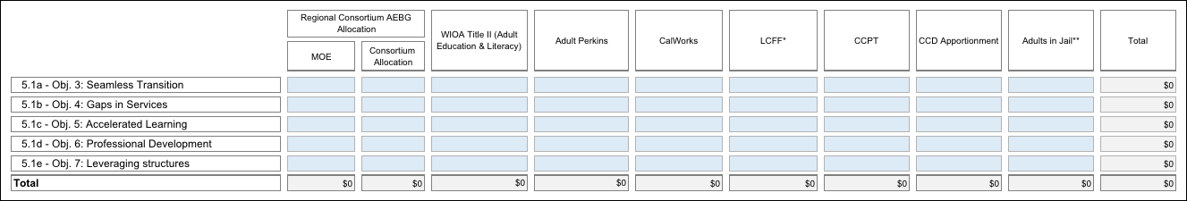
EXAMPLE

Section 6: Levels of Service and Assessment of Effectiveness
6.1 Projected Levels of Service. Provide a the number of students served in 2013-14 as identified in your AB86 Final Plan, as applicable, and target numbers for each of the AB104 AEBG Program Areas listed in the table shown below. Estimates for the figures for the new AB104 AEBG program areas (Pre-Apprenticeship training, Adults training to support child school success, and Adults in the Workforce, Including Older Adults) are acceptable. Duplicated headcounts are acceptable as some students may be in more than one program. You may add notes to explain your baseline and target figures, if necessary. It is understood that these figures will change over the course of implementation, so this would be your best estimate at this time.
Using the Performance Measures Workbook for Table 6.1, Consortium Members will fill out their own spreadsheets. The spreadsheets completed by individual Members will automatically be totaled together to provide the Consortium level figures on the Summary Page of the Workbook. Below is an overview of the information required.
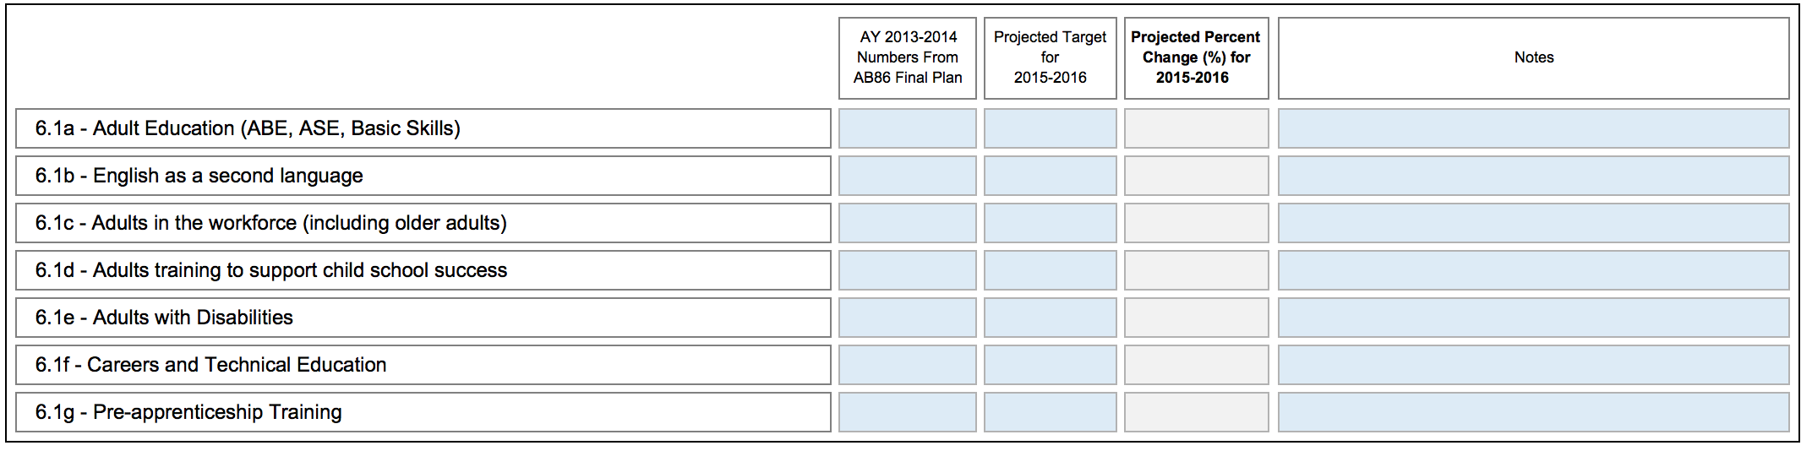
EXAMPLE
Table 6.1 Levels of Service by Program Area and Member (Projected Targets)

6.2 Project Performance Outcome Targets. Provide target percentages for each of the performance measures listed in the table shown below. See the Guidance document for more information on this section, and resource links for goal-setting approaches.

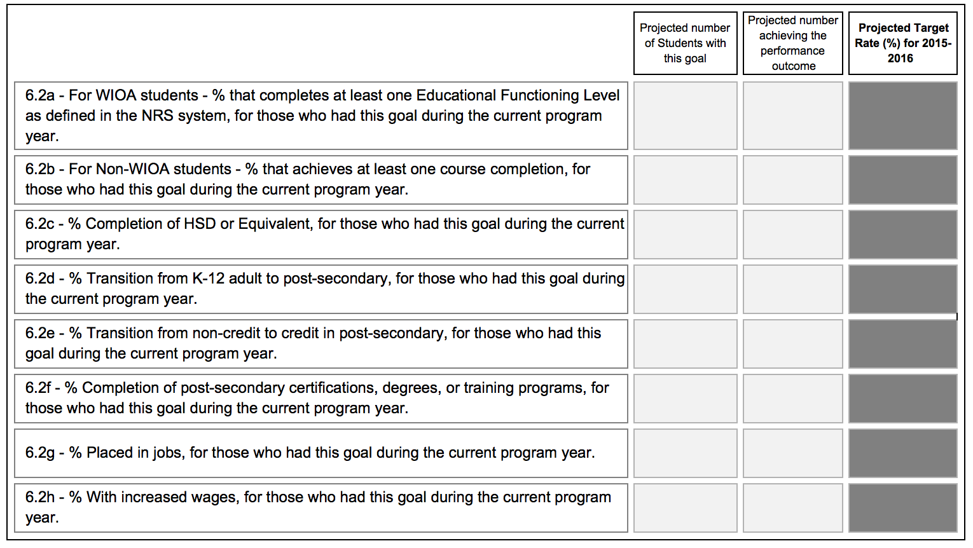
Using the Performance Measures Workbook for Table 6.2, Consortium Members will fill out their own spreadsheets. The spreadsheets completed by individual Members will automatically be totaled together to provide the Consortium level figures on the Summary Page of the Workbook. Below is an overview of the information required.
Table 6.2: Performance Outcomes by Member – Projected Targets
If you have unique, extenuating circumstances that you wish to describe regarding any of these measures, please name the measure by number and briefly describe the issue.

The Performance Outcomes by Member – Projected Targets (Table 6.2) is to be determined.

6.3 List and describe any additional measures your Consortium will be tracking in order to gauge the impact of the Consortium’s plan efforts. (Optional – see Guidance document for information)

No Comment
6.4 List and describe the approaches or measures you as a Consortium will be looking at to evaluate the effectiveness of your Consortium. (Required)
Our Consortium will seek to accurately track job placement information on adult education students. We will work closely with the EDD, community organizations, and industries to successfully provide job placement and tracking data of adult learners. Likewise, we will attempt to document job progression of students as a measurement of our Consortium’s effectiveness.
Additional data, such as program participation numbers and student surveys will add insight to the Consortium’s effectiveness towards community awareness, outreach efforts, and overall public involvement with Adult Education initiatives.

Section 7: Consortium Member Signature Block
Name: | Dr. Terri Long
Consortium Member: | LBCCD
Email: | tlong@lbcc.edu
Date:
Signature Box:

Name: | Carol Ortega
Consortium Member: | LBUSD
Email: | cortega@lbschools.net
Date:
Signature Box:

Name: | Dr. Felicia Anderson
Consortium Member: | LBUSD
Email: | fanderson@lbschools.net
Date:
Signature Box:

