Revised Adult Education Block Grant
Annual Plan Template for 2015-16
Updated 5-15-2017

Section 1: Consortium Information

1.1 Consortium Grant Number:
15-328-10
1.2 Consortium Name:
Contra Costa County Adult Education Consortium

1.3 Primary Contact Name:
G. Vittoria Abbate

1.4 Primary Contact Email:
abbategv@mdusd.org

If applicable:

1.5 Fiscal Agent Name:
1.6 Fiscal Agent Email:
LKhan@cccoe.k12.ca.us
Contra Costa County Office of Education (CCCOE)

1.7 Identify each member organization currently within your Consortium, and your Consortium representative.
Table 1.7 – Consortium Membership (add rows as needed)
1.7a. Organization | 1.7b. Representative Name | 1.7c. Representative Phone | 1.7d. Representative Email | 1.7e. Date Officially Approved
Acalanes Union HSD | Steve France | 925/280-3945 | sfrance@acalanes.k12.ca.us | 8/12/2015
Antioch USD | Dr. Michael Santos | 925/779-7500 | mikesantos@antioch.k12.ca.us | 10/14/2015
Contra Costa Community Colleges District Office (CCCCD)
Contra Costa College | Jason Berner Mojdeh Mehdizadeh | 510/215-4131  510/215-3801 | jberner@contracosta.edu mojdeh@4cd.edu | 12/10/2015  12/10/2015
Diablo Valley College | Kim Schenk  Emily Stone | 925/969-2036  925/969-2113 | kschenk@dvc.edu estone@dvc.edu | 12/10/2015  3/23/2016
Los Medanos College | Kevin Horan  Nancy Ybarra | 925/473-7401  925/473-7405 | khoran@losmedanos.edu nybarra@losmedanos.edu | 12/10/2015  12/10/2015
Contra Costa County Office of Education | Rachelle Buckner Lindy Khan | 510/262-4341  925/942-3343 | rbuckner@cccoe.k12.ca.us lkhan@cccoe.k12.ca.us | 1/15/2016  1/15/2016
Liberty HSD | Debbie Norgaard Guy Rognlien | 925/634-2565  925/634-2589 | norgaard@libertyuhsd.k12.ca.us rognlien@luhsd.net | 9/9/2015  9/9/2015
Martinez USD | Kathy Farwell | 925/228-3276 | kfarwell@martinezusd.net | 8/10/2015
Mt. Diablo USD | Vittoria Abbate Jennifer Sachs | 925/685-7340  925/682-8000 | abbategv@mdusd.org sachsj@mdusd.org | 11/16/2015  11/16/2015
Pittsburg USD | Anthony Molina Lynne Nicodemus | 925/473-2314  925/473-4460 | amolina@pittsburg.k12.ca.us lnicodemus@pittsburg.k12.ca.us | 12/10/2015  12/10/2015
West Contra Costa USD | Paul Shatswell  Connie Pekedis | 510/231-1453  510/231-1453 | pshatswell@wccusd.net  cpekedis@wccusd.net | 10/5/2016  10/5/2016

1.8 Use the Governance Template to describe how your Consortium operates programmatically and fiscally.

1.9 Attach an organizational chart to this plan submission. Show member relationships (including reporting) and interface with key partners, and identifying the fiscal agent (if applicable) and primary contact. See Guidance for sample and definitions.

1.10 Whether using a single fiscal agent or not, describe how you are fiscally managing your block grant. How are you rolling up grant expenditures to certify and report to the State? Who will be your Certifying Officer?
The Contra Costa County Adult Education Consortium (CCCAEC) has elected to have a Fiscal Agent in Year 1 (2015-2016) and the Fiscal Agent is the Contra Costa County Office of Education (CCCOE). Budget information and expenditures are being gathered from each member organization to be analyzed and reconciled and submitted to the State. Bill Clark is the Certifying Officer.

Section 2: Plan Summary for Program Year 2015-16

The AEBG effort focuses on the this purpose described in AB86: “… to rethink and redesign an educational system that creates seamless transitions for students across adult schools and community colleges to accelerate academic and career success in order to earn a living wage.” Your AB104 Adult Education Block Grant Three-Year Plan Update summarizes what your Consortium’s vision and goals are for your regional Adult Education system by the end of the three-year implementation period (by the end of program year 2017-18). The annual plans will focus on what will be done to make progress towards that vision.

2.1 Provide an Executive Summary regarding how your Consortium proposes to make progress in program year 2015-16 towards the realization the vision and goals of your Consortium’s AB104 AEBG Three-year Plan referred to above. What will your system look like by the end of 2015-16? See Guidance document for more information about this narrative.
The Contra Costa County Adult Education Consortium (CCCAEC), during the revision of its 3-year plan and budget, retooled the first year plan to determine what in the plan was actionable during the first year, 2015-16. During this process, each member was tasked with retooling their individual plans to inform the collective regional plan. Upon completion of this step, the Steering Committee met to act on the recommendation of the Budget Sub-committee to accept the proposed individual member revised plans.

At the end of 2015-16, the CCCAEC plans to have the following components in place:

- Standing sub-regional faculty and staff workgroups for Basic Skills, ESL and Career Technical Education
- Consortium Manager hired to manage “business” of the Consortium: arranging monthly and special meetings of the Steering Committee, Consortium budget development & monitoring, assist Fiscal Agent, preparation of deliverables, AEBG reports & reporting, facilitation of sub-regional faculty & staff workgroups, facilitation of Steering Committee workgroups, website updating, community outreach & engagement, etc.
- Workgroups: Budget & Fiscal; Assessment & Data; and, Pathways & Transitions
- Curriculum alignment mapping well underway for Basic Skills, ESL and Career Tech Education
- Transition Specialists for cross-referrals between, and for, K-12 adult schools and community colleges hired
- Support services currently offered by K-12 adult schools and community colleges being “leveraged” by Transition Specialists for transition of students between systems
- Begin leveraging regional Career Pathways Trust (CPT) and workforce development resources to support Consortium initiatives and work (This began in 2016-17)
- Establishment of process for developing systemic articulation agreements (This began in 2016-17)
In addition, the CCCAEC intends to reassess mid-year (by the end of 2015-2016), the Consortium Annual Plan implementation and expenditures to make any adjustments necessary at that time.

Section 3: Consortium Services and Funding Allocations
3.1 Consortium Services by Program area, Member and Funding Source (Estimated). Please identify the types of services your Consortium will provide, and the funding that will go to support these efforts. Information about Levels of Service will be gathered in Section 6. Using the Member Allocations Workbook for Table 3.1, Consortium Members will fill out their own spreadsheets. The spreadsheets completed by individual Members will automatically be totaled together to provide the Consortium level figures on the Summary Sheet of the Workbook. Below is an overview of the information required.
Administration and MOE Indirect amounts are captured in Table 3.2b. The amounts entered in Table 3.1 should not include those expenses.
Table 3.1 Consortium Services by Program area, Member and Funding Source (Estimated)

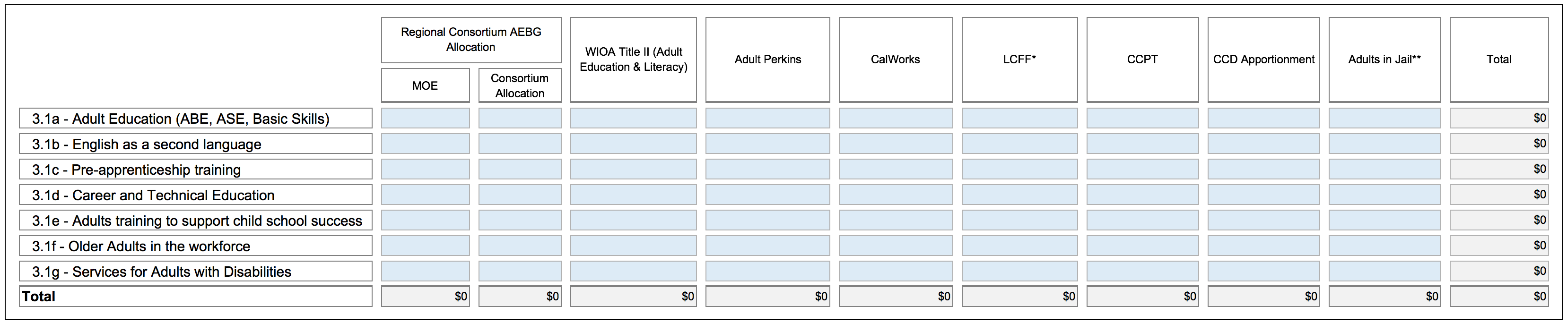
EXAMPLE

REVISED 3.2 Consortium AEBG Allocations by Member (Estimated).
NEW INSTRUCTION: Table 3.2 will capture total AEBG MOE and Consortium Allocations, and the amounts of those figures that will go Administration (5% cap) and the MOE Indirect amount that will be charged to the AEBG. Using the Member Allocations Workbook for Table 3.2, Consortium Members will fill out their own spreadsheets. The spreadsheets completed by individual Members will automatically be totaled together to provide the Consortium level figures on the Summary Sheet of the Workbook. Below is an overview of the information required.
Table 3.2 Consortium Allocations by Member (Estimated)
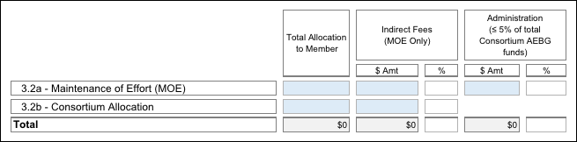
EXAMPLE
Section 4: Overview of 2015-16 Action Plans
Building off of your AB86 Final Plan, your AB104 Three-Year Consortia Plan Update and expected accomplishments for the 2015-16 program year, briefly outline your Consortium’s top 3-5 key activities for each of the Plan Objectives listed below for 2015-16. The original AB86 Objectives language has been adapted to the AB104 AEBG context.
4.1 Objective 3: Integrate existing programs and create seamless transitions into postsecondary education or the workforce. How will the Consortium align and connect existing and future adult education programs to postsecondary academic pathways and/or career pathways leading to employment? Activities should address how the Consortium will align placement tools, curriculum, assessment tools and rubrics, and student performance outcomes across delivery systems to ensure that student transition paths, both between providers and into postsecondary credit programs, are understood and supported across all systems.

Plans to facilitate transitions from adult education to college or career should include activities to support program alignment and pathways. Plans should also address support services needed to ensure that students have access to educational advising and that they develop educational plans to help them move toward their academic and career goals. Describe the specific activities the Consortium will employ to create the following:
● Educational pathways
● Alignment of:
○ Placement
○ Curriculum
○ Assessments
○ Progress indicators
○ Major outcomes - i.e., awards of high school diplomas, CTE certificates, etc.
● Transition strategies among the Consortium participants’ systems including:
○ Communication paths among Consortium participants and higher education institutions
○ Defined and articulated pathways to postsecondary education or the workforce
○ Embedded access to student services including counseling, guidance, and follow-up

4.1a Provide a description of your AEBG Regional Assessment Plan, i.e. how students will be appraised, placed, assessed, etc. into the regional adult system, as they progress, and as they move among the various schools. What tools and vendors will you be using for these activities?
The Contra Costa County Adult Education Consortium (CCCAEC) has established a Data workgroup that coordinates with a Bay region wide Data workgroup and three (3) CCCAEC sub-regional faculty and staff work groups already formed for Basic Skills, Career Technical Education and ESL. The CCCAEC Data work group is responsible to the Consortium Steering Committee to make recommendations on common assessments and data collection and sharing protocols in all program areas to be piloted in 2017-18. CCCAEC is principally working with CASAS TopsPRO and sourcing other vendors in collaboration with the regional data group. CCCAEC intends to use the AE tab in LaunchBoard for program assessment as that data is collected, cleaned and becomes meaningful. CCCAEC has a state approved data plan and has allocated funding to all partners to upgrade and update data collection systems.

Sub-regional faculty and staff workgroups are mapping program entry and exit points, steps that would lead to program alignment and congruence across each system (congruence among K-12 adult schools and congruence among the three community colleges).

Mapping of the current entry and exit points, current expected learning outcomes compared to current student outcome data, etc. are being worked on internally by each system (K-12 adult schools and community colleges) to prepare for future discussion about expected outcomes from K-12 adult schools to align to community college entry requirements.

4.1b Describe how you will track student enrollment, demographics, and performance. What system(s) will you be using? How will you collect the data from the student/classroom level? How will this system enable you to meet the targeted program outcomes?
The Data and Accountability Workgroup meets monthly. CCCAE has a state approved data plan and has allocated funding to all partners to upgrade and update data collection systems. The Data and Accountability work group is managing these awarded state funds to develop systems to track student enrollment, demographics, and performance. As stated above, CCCAE is principally working with CASAS TopsPRO as well as sourcing other vendors in collaboration with the Bay Area regional data group. Student/classroom data will be collected by each partner and reported through either TOPsPRO or community college MIS. Demographics, program and transition data will be collected using other systems that are currently under review. This yet-to-be adopted system will enable CCCAE to document targeted program outcomes. In addition, CCCAE intends to use the AE tab in LaunchBoard for summative program assessment as that data is collected, cleaned, and becomes meaningful.

4.1c – Objective 3 continued: List other activities to integrate existing programs and create seamless transitions into postsecondary education and/or the workforce.

Table 4.1c – Objective 3: Other Key Integration and Seamless Transition Activities (add rows as needed)
4.1c(1). Activity | 4.1c(2). Timeline | 4.1c(3). Consortium Members Involved | 4.1c(4). Outcomes  Expected | 4.1c(5).Method of Assessing Impact
Sub-regional faculty/staff workgroups: Basic Skills, Career Tech Ed & ESL | Already underway since the inception of AEBG Consortia in 2014-15 | K-12 Adult School and Community College program administrators & faculty | Curriculum mapping, alignment and possible development of common assessments | Adoption of common rubrics, norming of graduation requirements and alternatives to graduation requirements at all AE sites.
Consortium Manager | April 1, 2016 | Steering Committee Co-chairs | Facilitation of building Consortium structure and organization as well as management of Consortium business, programs  & activities | Formal performance review at the end of initial eleven (11) months of Independent Services Contract. The performance evaluation tool was developed by the Governance Work group and approved by the Steering Committee. The first performance review was completed by all members of the Steering Committee and work group chairs, summarized and shared with all, along with the CM’s self-evaluation. Results were shared with the CM.
Apprenticeships | 2017-18 | Mt. Diablo USD, Martinez USD | Development of 1-2 apprenticeship programs in 2016-17 | TBD
Bridge Programs | 2015-16 | Mt Diablo USD  DVC (CCCCD)  CCC (CCCCD)  CCAS (COE) | Identification of “Best Practices” model components based on current Mt. Diablo USD “Building Skills for the Trades” and Project ACCESS (ECE) bridge programs from Mt. Diablo Adult Ed (MDAE) to Diablo Valley College (DVC) for possible replication to other content areas.  CCAS (County Office of Education) has an articulation agreement with Contra Costa College to award college credit by exam to inmate/students enrolled in Computer Applications class. | Assessment of impact will be based on development of a new instrument that can identify and measure “successful student transition points” from K-12 Adult Schools (MDAE) to Community Colleges (DVC)  Number of students awarded college credit by exam in Computer Applications class
Transition Specialists | 2016-17 | All (seven K-12 Adult Schools, Contra Costa County Office of Education, three community colleges) | Initially in 2016-17, lattice or cross- referrals from K-12 Adult Schools to Community Colleges and vice versa, based on student needs assessments yet to be developed and used in tandem with current Adult School and Community College instruments for this purpose. | Numbers of students transitioned, persistence, course trajectories, etc.  Specific data elements and tool(s) or instrument(s) for measuring and assessing impact, yet to be developed.
Transition and Supportive Services | 2016-17 | Mt Diablo USD | Mt. Diablo Adult Education’s Adults with Disabilities (AWD) will purchase a passenger van to provide job/higher education services to students in the AWD department, providing services to students in the TOPS (Asperger’s high-functioning autism), On Track Programs (Acquired Brain Injury) and Life Skills students. | Transportation provided to potential employer/volunteer/internship sites and the America’s Job Center, community colleges and other vocational training locations in support of existing and developing programs.

4.2 - Objective 4: Activities to address the gaps identified in Objective 1 (evaluation of current levels and types of adult education programs within its region, and Objective 2 (evaluation of current needs for adult education programs within the Consortium’s region), updated in your Updated AB104 3-year Plan. Describe how the Consortium will respond to the gaps identified in the region. These might include, but are not limited to, working with other partners in the service area, developing or expanding programs and plans to assess the effectiveness of these expanded efforts.

Plans will have identified programming and service gaps including lack of providers, services, access, attainment, and/or performance. Activities to address these should include strategies to incrementally increase capacity in identified gap areas (e.g., using distance learning to reach adult populations in a Consortium’s region who are currently underserved).

Table 4.2 - Objective 4: Key Activities for Addressing Gaps (add rows as needed)

4.2a. Activity | 4.2b. Timeline | 4.2c. Consortium Members Involved | 4.2d. Outcomes  Expected | 4.2e. Method of  Assessing Impact
Recruitment & hiring of Consortium Manager | April 1. 2016 | Co-chairs, G. Vittoria Abbate (Mt. Diablo USD), Dr.  Andrew Jones (CCCCD), Lynne Nicodemus (Pittsburg USD) &  Steve France (Acalanes HSD) | Organizational support and facilitation support of sub-regional groups | Outcomes-based performance Independent Services Contract by Mt. Diablo USD on behalf of  Consortium
Development of enhanced and new partnerships with CBOs, business & industry county- wide | 2016-2018 | All | Increased collaboration for student support services, training  opportunities for students | Increase in number of formal collaborations by means of MOUs and increase in number of collaborative training programs
Establishment of CTE programs in Antioch USD | 2016-2018 | Robert Beck & Dr. Michael Santos, Antioch USD | Establishment of initial CTE course(s) | Student course completions and transitions to post- secondary and/or jobs/careers, student surveys
Development of enhanced and new partnerships with CBOs, business & industry county- wide | 2016-2018 | All | Increased collaboration for student support services, training  opportunities for students | Increase in number of formal collaborations by means of MOUs and increase in number of collaborative training programs
Enhance Family Literacy Centers for student support services | 2016-2018 | G. Vittoria Abbate, Mt. Diablo USD; Lynne Nicodemus, Pittsburg USD | Increased student support services for students in Family Literacy programs for transitioning to other adult education and post- secondary programs | Increased number of students receiving support and transition services, as well as, increase in variety and type of services available to students
Expansion of High School Diploma program | 2015-16 | Debbie Norgaard, Liberty HSD | Addition of evening HSD classes | Increase in HSD student enrollment, number of students  & increase in number of graduates
Restore ESL in East County | 2016-2018 | Debbie Norgaard, Liberty HSD | Restoration of ESL classes day & evening classes that were cut during 2008-09 state-wide budget reductions | Increased number of day & evening ESL classes, increase in student enrollment in these classes and increase in student gains as reported through CASAS annual reporting

4.3 - Objective 5: Employ approaches proven to accelerate a student’s progress toward his or her academic or career goals, such as contextualized basic skills and career technical education, and other joint programming strategies between adult education and career technical education. Research has emerged in recent years identifying practices that reduce the time it takes for adult learners to progress through basic skills and career education pathways. Common strategies include compressing courses into shorter, more intensive terms (accelerated), individualized instruction based on a student’s competencies (competency-based), and putting basic skills content into the context of a student’s goals and career path (contextualized).
Many examples of these “best practices” are already in place within and among California adult education and community college programs. These “best practices” are not new to faculty; in fact, they have been developed by faculty. AB104 expects that the work done by regional consortia will include plans to make use of these strategies within their basic skills and career programs and in joint programming strategies.
In many places in the country, Integrated Basic Skills Training (IBEST) models, which contextualize the development of basic skills with the acquisition of workforce competency, have produced impressive data showing how learning can be accelerated while joining skills development with career readiness certifications. The AB104 website will continue to build links and resources tied to best practices and research done through adult education and community colleges.
Identify activities that you will implement and/or improve through using specific evidence-based strategies across the region, within and between systems where they currently don’t exist, to accelerate student’s progress.
Table 4.3 - Objective 5: Key Activities for Accelerating Student Progress (add rows as needed)
4.3a. Activity | 4.3b. Timeline | 4.3c. Consortium Members Involved | 4.3d. Outcomes  Expected | 4.3e. Method of  Assessing Impact
Alignment of ESL programs across K- 12 system to create congruence to subsequently facilitate articulation from ESL to ABE or HSD as well as ESL to CTE. | 2016-2018 | All (via faculty/staff sub-regional – Central, East & West County – plus cross-regional workgroups) | Program congruence by means of development of common placement standards and common assessments; ESL Workgroup has adopted the CB21 rubric as their norming document and are working to align curriculum and course sequencing | Increased articulation agreements and seamless transitions for students
Student transition planning information & supports from K-  12 Adult Ed CTE to Community Colleges CTE programs | 2016-2018 | All (via faculty/staff and cross-regional workgroups) | Articulation agreements between K-12 Adult Ed and Community College CTE programs that are  systemic & between institutions rather than only faculty member to faculty member | Increase of systemic articulation agreements between K-12 Adult Ed and Community Colleges  & increase in number of students transitioned from K-12 Adult Ed to Community College CTE programs
Expansion of CTE partnerships with regional business  & industry partners | 2016-2018 | All | Increase in number of of CTE partnerships by and between K-12 Adult Ed & business/industry partners as well as between Community Colleges & business/industry  partners | Increase in number of formal partnerships and MOUs between institutional members and regional businesses/industries
Articulation of Mt. Diablo USD K-12 Adult Ed (MDAE) EMT program with Los Medanos College (LMC) for  Emergency  Medical Transport (EMT) + Business Occupations Training (BOT)  with Diablo Valley College | 2016-17 | Mt. Diablo USD K- 12 Adult Ed (MDAE), Diablo Valley College (DVC), and Los Medanos College (LMC)  In progress among all consortium members. | Articulation agreements that are systemic between institutions rather than only between  faculty members of institutions | Registration & enrollments in articulated programs  + persistence of students enrolled in articulated program + number of completion from articulated Community College program
Development of a co-enrollment program between West Contra Costa Adult Education (WCCAE) ESL &  Contra Costa College (CCC) Early Childhood Education (ECE) & CTE programs | 2016-2018 | West Contra Costa Adult Education (WCCAE) & Contra Costa College (CCC) | Establishment of a co-enrollment ESL/Early Childhood Education (ECE) & CTE programs | Registration & enrollment of students in co-enrollment program, persistence in each program + completions from each program
Development of a learning community to support adult education students entering the automotive services program | 2017-18 | Contra Costa College | Students will be placed in a cohort and benefit from contextualized basic skills and counseling courses | Students will earn an industry-recognized, non-credit certificate to improve their employment and earning potential

4.4 - Objective 6: Collaborate in the provision of ongoing professional development opportunities for faculty and other staff to help them achieve greater program integration and improve student outcomes. A critical element to ensuring the effective implementation of the Consortium’s plans to improve adult education programs are faculty and staff equipped with the skills, knowledge, and support needed to deliver high-quality instruction and use classroom support strategies that foster learner persistence and goal achievement. Significant and effective professional development will be required to build capacity within the existing systems to deliver this new vision for adult learning throughout the state.

Faculty and staff from all local Consortium members and partners will need to implement collaborative professional development strategies to foster alignment and to support ongoing assessment and improvement of student outcomes.
Collaborative professional development plans should identify topic areas the Consortium considers a priority, such as:
● Practices in basic and secondary skills that build the “college readiness” skills.
● Team building, critical thinking, problem solving, study skills, soft skills, and career assessment.
● Technology use and integration to enhance and expand technology in Instruction.
● New models and instructional strategies for contextualized and/or accelerated teaching and learning.
● Skills building intercultural competence among faculty, staff, and administrators.

Examples of collaborative activities might include developing professional learning communities comprising faculty in the same content area, representing all Consortium participants. Plans might also describe joint team participation in professional development activities offered through regional/statewide associations and how these teams might share what they learn with other faculty. Consortia may also want to consider having field experts come to a regional facility to provide in-house training to greater numbers of staff, faculty and administrators. Consortia in areas where transportation may pose a problem may want to develop plans to use technology to overcome that challenge.

List activities that your consortium will implement to collaborate in the provision of ongoing professional development opportunities for faculty and other staff to help them achieve greater program integration and improve student outcomes.

Table 4.4 - Objective 6: Key Activities for Professional Development Collaboration (add rows as needed)
4.4a. Activity | 4.4b. Timeline | 4.4c. Consortium Members Involved | 4.4d. Outcomes  Expected | 4.4e. Method of  Assessing Impact
Facilitation Training | 2017-18 | All institutional member representatives | Increase in knowledge base of Consortium Leadership Steering Committee members to facilitate cross- system meetings of faculty and staff | TBD
ESL data discussions between Mt. Diablo USD K-12 Adult Education (MDAE) and Diablo Valley College (DVC) | 2016-2018 | Mt. Diablo USD K- 12 Adult Ed (MDAE), Diablo Valley College (DVC) | ESL program alignment between Mt. Diablo USD K- 12 Adult Ed (MDAE), Diablo Valley College (DVC) | Successful transition of 20 students from Mt. Diablo USD K- 12 Adult Ed (MDAE), Diablo Valley College (DVC) ESL program as evidenced by “warm hand-offs”, in Spring 2017 with student persistence in DVC ESL program + student completions in DVC ESL  programs
Math instruction professional development opportunity for East County K-12 Adult Education and Community College faculties | 2016 | Antioch USD K-12 Adult Education, Pittsburg USD Adult Education, Liberty HSD Adult Education and Los Medanos College | Expanding knowledge base of K-12 and community college adult education faculty on basic math instructional strategies for adult learners | TBD
Community Colleges workshops on Career Ladders Project | This activity was determined to be a poor use of funds and was not conducted. | All | Expanding knowledge base of all CCCAEC institutional members regarding Career Ladders Project for future discussion on possible regional county-wide “scaling up” for adult learners of member institutions | TBD
AEBG Summit | 2015 | Five (5) member  institutions (5 representatives) participated: Diablo  Valley College, Mt. Diablo Adult Education, Acalanes Adult Education, Pittsburg Adult Education and Contra Costa County Office of Education Jail Ed program | Increase in knowledge base of AEBG guidelines for local consortium  work + developing a base of information regarding current developments in consortia plans and planning state-wide | TBD

4.5 - Objective 7: Leverage existing regional structures, including, but not limited to, with local workforce investment areas. Describe how the Consortium will leverage existing assets or structures to benefit the adult learners in the region. These assets or structures might include, for example, contributions from or collaborations with local Workforce Investment Boards (WIBs), industry employer groups, chambers of commerce, and county libraries.

For example, a Consortium might include in its plan to offer classes, taught by one of the member districts, at a local Workforce Development Center which is easily accessible by members of the community. Another Consortium might opt to work with the industries in its region to develop a career transition program focused on helping students with disabilities gain the necessary skills to enter the workforce.

Partners might include but are not limited to:
○ WIBs
○ Chamber of Commerce
○ County Libraries
○ County Office of Education
○ Industry Employer Groups
○ Literacy Coalitions
○ Economic Development Regions
○ County Social Services - CalWorks
○ Employment Development Department (EDD)
Examples of activities include:
○ Outreach by the regional Consortium to existing regional structures not yet involved Adult Education that could address a gap or need
○ Expanding utilization of existing regional resources for Adult Education students
○ Participation of Consortium Members in organizations that involve employers, Economic and Workforce Development to enhance responsiveness to economic needs

List activities to leverage existing regional structures and utilization of resources.

Table 4.5 - Objective 7: Key Activities for Leveraging Structures and Assets (add rows as needed)
4.5a. Activity | 4.5b. Partner(s) | 4.5c. Contribution(s)  Made | 4.5d. Consortium  Members Involved | 4.5e. Timeline | 4.5f. Outcomes  Expected | 4.5g. Method of  Assessing Impact
Regional Resource Mapping | Workforce Development Board (WDB), AJCC  One Stop Consortium, Contra Costa County Libraries (Project Second Chance), Catholic Charities of East Bay, Monument Impact, Opportunity Junction, West Contra Costa County Libraries (Project Read), First 5 Contra Costa, Employment and Human Services Development, Employment Development Department, Department of Rehabilitation | East Bay Economic Outlook 2014-  2015 and the  2013 Special Report on the East Bay Workforce | All | 2015-17 | Outreach to adult learners regarding resources in the community and cross- training of staff and partners to establish a cross- referral network | Usefulness will be assessed by Member Institutions from input from Support Staff (such as Transition Specialists) using WDB tool/instrument to be developed
Career Pathways  Trust Grant (CPT Grant) | Contra Costa Community Colleges, Mt. Diablo USD, Martinez USD,  Pittsburg USD, West Contra Costa USD and Antioch USD | Regional participation and emerging collaboration to leverage staffing resources,  develop systemic articulation agreements, etc. | Contra Costa Community Colleges, Mt. Diablo USD, Martinez USD,  Pittsburg USD, West Contra Costa USD and Antioch USD | Currently in process/ operational | Basic Education (ABE), Adult Secondary Education (ASE), students of K-12 Community College Adult Education Programs | Data elements to assess impact being discussed and developed;  CTE programs and bridges are being designed as part of career pathways.
Dedicated time during Consortium Steering Committee meeting for discussion about leveraging all institutional member resources per AB104 Assets Allocation chart (MOE, Perkins Grant, Career Pathways Trust, etc.) for forward planning and support of Consortium Regional Plan | None. This activity is specific to leveraging resources of Consortium Member Institutions at this point in time. | TBD | All | April 2016 | All members complete an additional funding sources document to review along with member allocations. Budget Work Group to review and make recommendations to the Steering Committee regarding the regional needs of the consortium | Successfully leveraging and braiding of funds for bridge building and program expansion

Section 5: Estimated Allocations by Objective

5.1 Allocation by Objective, Member and Funding Source (Estimated). Provide an estimate of the budget the Consortium will plan to expend in order to carry out the activities (including those not listed above) relevant to each Objective. It is understood that these figures will change over the course of implementation, so this would be your best estimate at this time. Using the Member Allocations Workbook for Table 5.1, Consortium Members will fill out their own spreadsheets. The spreadsheets completed by individual Members will automatically be totaled together to provide the Consortium level figures on the Summary Sheet of the Workbook. Below is an overview of the information required.
Administration and MOE Indirect amounts are captured in Table 3.2b. The amounts entered in Table 5.1 should not include those expenses.
Table 5.1 - Allocation by Objective, Member and Funding Source (Estimated)

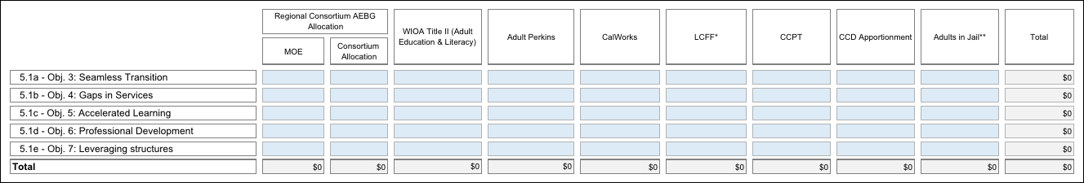
EXAMPLE

Section 6: Levels of Service and Assessment of Effectiveness
6.1 Projected Levels of Service. Provide a the number of students served in 2013-14 as identified in your AB86 Final Plan, as applicable, and target numbers for each of the AB104 AEBG Program Areas listed in the table shown below. Estimates for the figures for the new AB104 AEBG program areas (Pre-Apprenticeship training, Adults training to support child school success, and Adults in the Workforce, Including Older Adults) are acceptable. Duplicated headcounts are acceptable as some students may be in more than one program. You may add notes to explain your baseline and target figures, if necessary. It is understood that these figures will change over the course of implementation, so this would be your best estimate at this time.
Using the Performance Measures Workbook for Table 6.1, Consortium Members will fill out their own spreadsheets. The spreadsheets completed by individual Members will automatically be totaled together to provide the Consortium level figures on the Summary Page of the Workbook. Below is an overview of the information required.
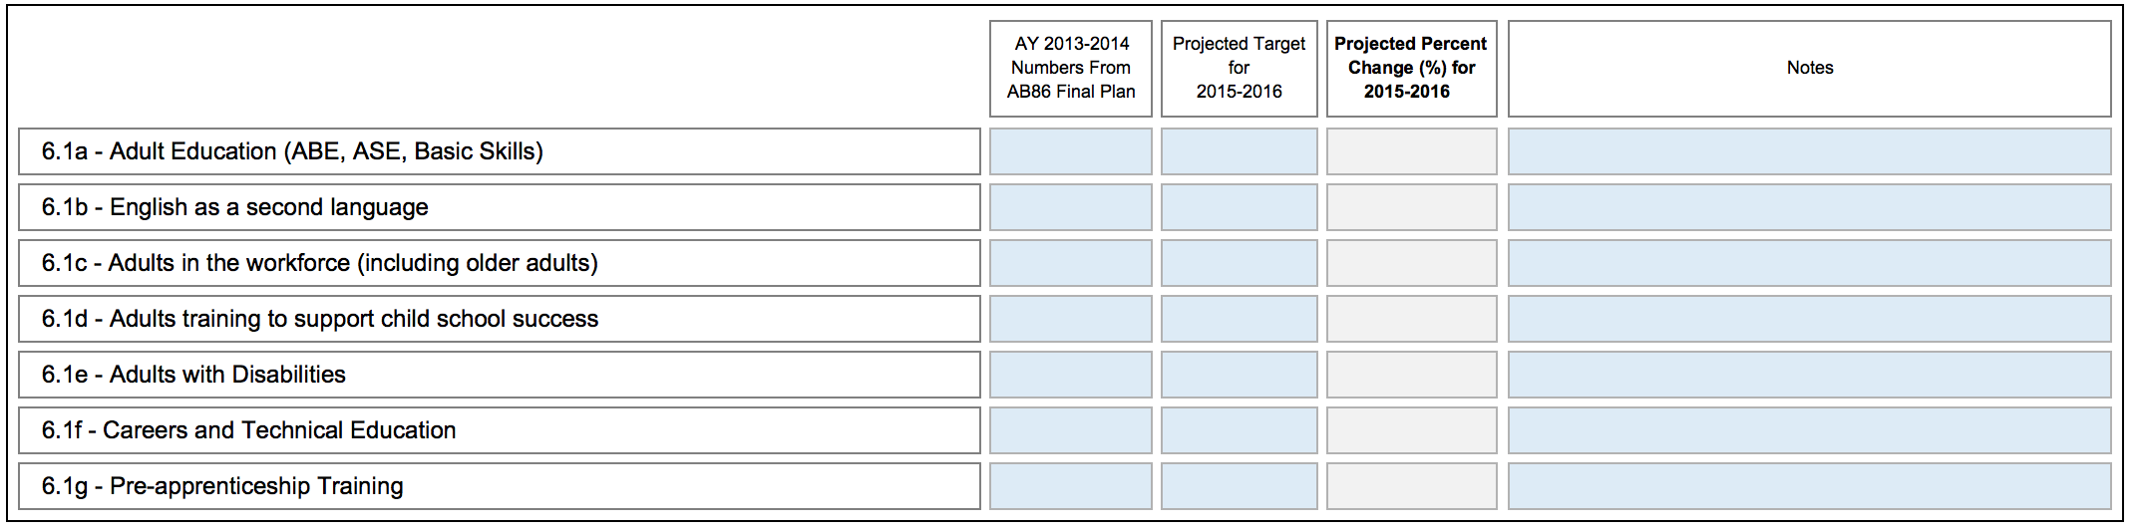
EXAMPLE
Table 6.1 Levels of Service by Program Area and Member (Projected Targets)

6.2 Project Performance Outcome Targets. Provide target percentages for each of the performance measures listed in the table shown below. See the Guidance document for more information on this section, and resource links for goal-setting approaches.

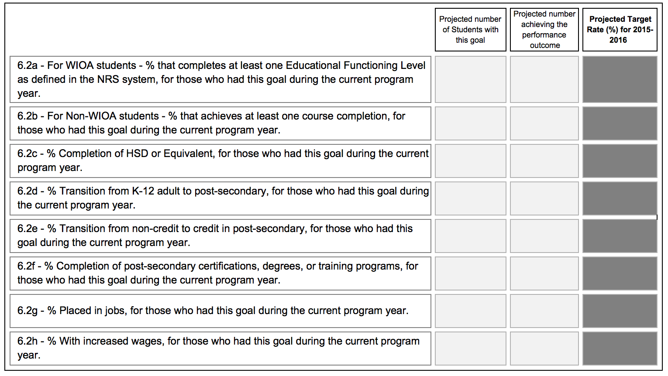
Using the Performance Measures Workbook for Table 6.2, Consortium Members will fill out their own spreadsheets. The spreadsheets completed by individual Members will automatically be totaled together to provide the Consortium level figures on the Summary Page of the Workbook. Below is an overview of the information required.
Table 6.2: Performance Outcomes by Member – Projected Targets
If you have unique, extenuating circumstances that you wish to describe regarding any of these measures, please name the measure by number and briefly describe the issue.

Please refer to the attachments from each and all member institutions regarding Project Performance Target Outcomes per Item 6.2 above. There are no unique or extenuating circumstances to report and describe at this time.

6.3 List and describe any additional measures your Consortium will be tracking in order to gauge the impact of the Consortium’s plan efforts. (Optional – see Guidance document for information)

No additional measures are expected to be tracked at this time, unless and until, an Assessment and Data Work Group makes a recommendation to the Steering Committee based on the work to be accomplished on data collection, analysis and systems as outlined in 4.1b above.
6.4 List and describe the approaches or measures you as a Consortium will be looking at to evaluate the effectiveness of your Consortium. (Required)

The Contra Costa County Adult Education Consortium (CCCAEC) has established a Governance work group, whose charge includes development of specific or exact approaches or measures that will be used to evaluate the effectiveness of the Consortium. It is anticipated that the evaluation process will include feedback and information from: the Consortium Manager, students, community and work group review of data with information gathered through surveys, focus groups, from input at public presentations/meetings, via the CCCAEC website, etc.

Section 7: Consortium Member Signature Block
Name:
Consortium Member:
Email:
Date:
Signature Box:

Name:
Consortium Member:
Email:
Date:
Signature Box:

Name:
Consortium Member:
Email:
Date:
Signature Box:

Name:
Consortium Member:
Email:
Date:
Signature Box:

Name:
Consortium Member:
Email:
Date:
Signature Box:

Name:
Consortium Member:
Email:
Date:
Signature Box:

Name:
Consortium Member:
Email:
Date:
Signature Box:

Name:
Consortium Member:
Email:
Date:
Signature Box:

Name:
Consortium Member:
Email:
Date:
Signature Box:

Name:
Consortium Member:
Email:
Date:
Signature Box:

Name:
Consortium Member:
Email:
Date:
Signature Box:

